**Visvesvaraya Technological University**

**Belagavi, Karnataka**

**-**

**590 018**

A

Mini Project Report

On

“INTELLIFARM

-

SENSE HUB”

**A smart farming project based on the domain of IOT**

**.**

Submitted

i

n partial fulfillm

ent of the requirement

for the award of the

Degree of

**BACHELOR OF ENGINEERING**

in

**ELECTRONICS AND COMMUNICATION ENGINEERING**

by

**SANJANA A**

**137**

**VV21EC**

**4**

**S**

**OUPARNIKA S**

**4**

**149**

**VV21EC**

**V R NAKSHATRA**

**VV21EC**

**4**

**168**

**VAISHNAVI K**

**4**

**VV21EC**

**169**

Under the guidance of

:

**Department of Electronics and Communication Engineering**

**Vidyavardhak**

**a College of Engineering, Mysuru**

**-**

**02**

**202**

**3**

**-**

**202**

**4**

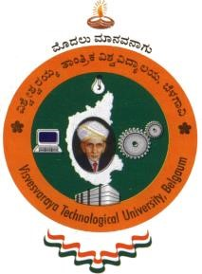

**Dr Chandrashekar M Patil,**

Professor & Head,

Dept. of ECE, VVCE.

**Vidyavardhaka College of Engineering,**

**Mysuru**

**–**

**5700**

**02**

Department of Electronics

and

Communication Engineerin

g

**CERTIFICATE**

This

is

to

certify

that

the

work

entitled

**“**

**Intellifarm**

**-**

**Sense Hub**

**”**

**(**

**A smart farming**

**project based on the domain of IOT**

**)**

is a

bona

fide work carried out by

:

**SANJANA A**

**137**

**VV21EC**

**4**

**SOUPARNIKA S**

**149**

**4**

**VV21EC**

**V R NAKSHATRA**

**VV21EC**

**4**

**168**

**VAISHNAVI K**

**VV21EC**

**4**

**169**

in partial fulfillment of the award of the degree of Bachelor of Engineering

in

Electronics

and Communication Engineering of Visvesvaraya Technological

University,

Belagavi,

during the year

202

3

-

202

4

.

It is certified that all corrections / suggestions indicated during internal assessment

have

been incorporated

in

the

report.

The

mini

project

report

has

been

approved

as

it

satisfies

the

academic

requirements in respect of the mini project work prescribed for the Bachelor of

Engineering

degree.

_______________



**Dr Chandrashekar M Patil,**

Professor & Head,

Dept. of ECE, VVCE.

# DECLARATION

We the members of the mini project team, studying in the V semester of Electronics and Communication Engineering, Vidyavardhaka College of Engineering, hereby declare that the entire mini project titled **“Intellifarm-Sense Hub” (A smart farming project based on the domain of IoT)** has been carried out by us independently under the guidance of **Dr. Chandrashekar M Patil,** Professor & Head, Department of Electronics and Communication Engineering, Vidyavardhaka College of Engineering. This mini project work is submitted to the Visvesvaraya Technological University, Belagavi, in partial fulfilment of the requirement for the award of the degree of **Bachelor of Engineering** in **Electronics and Communication Engineering** during the academic year 2023-2024.

This mini project report has not been submitted previously for the award of any other degree or diploma to any other Institution or University.

Place: Mysuru

Date: 07/03/2024

**Name of the Students USN Signature**

1. **Sanjana A** 4VV21EC137
2. **Souparnika S** 4VV21EC149

**3.V R Nakshatra** 4VV21EC168

**4. Vaishnavi K** 4VV21EC169

# ACKNOWLEDGEMENT

The satisfaction that accompanies the successful completion of any task would be incomplete without the mention of people who made it possible and whose constant guidance and encouragement crowned our efforts with success. We consider our privilege to express the voice of gratitude and respect to all those who guided us and inspired us in completion of this mini project.

We wish to express our gratitude to **Dr. B. Sadashive Gowda**, Principal, VVCE, for providing congenial working environment.

We are thankful to **Dr. C. M. Patil**, Professor and Head, Dept. of ECE, VVCE, for motivating us and allowing us to use the logistics of the department to complete this mini project successfully.

We express our sincere thanks to our guide **Dr. Chandrashekar M Patil,** Professor & Head, Department of ECE, VVCE, for **his** constant co-operation, support, and invaluable suggestions.

We extend our heartfelt gratitude to our mini project coordinators **Dr. Suchitra M**, Professor, Dept of ECE, VVCE and **Mrs. Girijamba D L**, Assistant Professor, Dept of ECE, VVCE for their timely support and motivation.

We would like to thank our parents for their constant moral support throughout the completion of this mini project.

Finally, last but not the least we would like to extend our deep sense of gratitude to our friends who always inspired us and encouraged us throughout the completion of this mini project.

**Name of the Students**

1. **Sanjana A**
2. **Souparnika S**

**3.V R Nakshatra**

**4. Vaishnavi K**

i

# ABSTRACT

The contemporary agricultural landscape faces formidable challenges stemming from inefficient resource management, disease outbreaks, and unpredictable weather patterns. In response, this project presents a comprehensive solution aimed at revolutionizing farming practices through the integration of cutting-edge technologies. By amalgamating automated irrigation systems, weather forecasting algorithms, crop health imaging techniques, and sensor networks, the project endeavours to optimize resource utilization, mitigate crop losses, and enhance overall agricultural productivity. At the core of this project lies the development of an automated irrigation system capable of dynamically adjusting watering schedules based on real-time moisture data and crop-specific thresholds. Additionally, leveraging weather data collected from reliable sources enables proactive irrigation adjustments, reducing water wastage and ensuring optimal growing conditions. Coupled with this, advanced image processing and AI algorithms are employed to analyse crop health, swiftly detect diseases, and recommend appropriate pesticide applications, thereby minimizing yield losses. Furthermore, the integration of sensor networks facilitates the collection of crucial environmental parameters such as temperature and moisture levels, providing farmers with actionable insights through intuitive dashboards. This holistic approach not only aims to enhance crop yield and quality but also contributes to sustainability by promoting efficient resource management practices.

ii

## TABLE OF CONTENTS

Acknowledgements i

Abstract ii

Index iii

List of Acronyms v

List of Figures vi

List of Tables vi

## INDEX

### CHAPTER 1 INTRODUCTION [01-14]

1.1 Background 01

1.2 Introduction 02

1.2.1 Characteristics 03

1.3 Problem Statement 04

1.4 Motivation 05

1.5 Existing System 07

1.6 Components Required 08

**CHAPTER 2 LITERATURE SURVES [15-18]**

2.1 Literature Surveys

### CHAPTER 3 METHODOLOGY [17 21]

3.1 Sensor Integration 19

3.2 Predictive Analytics algorithms & Detection Models 20

3.3 Alerts & Notification of weather parameters 21

3.4 Integration of Systems 22

**CHAPTER 4 APPLICATIONS [23-24]**

iii

**CHAPTER 5 ADVANTAGES AND DISADVANTAGES [25-26] CHAPTER 6 RESULTS AND DISCUSSION [27-29]**

6.1 Unique Features of the project 30

### CONCLUSION [30-31] REFERENCES 32

iv

# LIST OF ACRONYMS

List of Acronyms for the Project:

|  |  |
| --- | --- |
| 1. ESP32: | Espressif Systems' System-on-Chip microcontroller |
| 2. IoT: | Internet of Things |
| 3. API: | Application Programming Interface |
| 4. HTTP: | Hypertext Transfer Protocol |
| 5. MATLAB: | Matrix Laboratory |

1. AI: Artificial Intelligence
2. RFID: Radio-Frequency Identification
3. GPS: Global Positioning System
4. GSM: Global System for Mobile Communications
5. LTE: Long-Term Evolution
6. UART: Universal Asynchronous Receiver-Transmitter
7. PCB: Printed Circuit Board
8. CAD: Computer-Aided Design
9. RGB: Red Green Blue
10. PWM: Pulse Width Modulation
11. USB: Universal Serial Bus
12. HTTP: Hypertext Transfer Protocol
13. API: Application Programming Interface
14. GUI: Graphical User Interface
15. LED: Light Emitting Diode

v

# LIST OF FIGURES

|  |  |  |
| --- | --- | --- |
| **Fig no:** | **Figure name:** | **Page no:** |
| 1 | ESP32 Microcontroller | 9 |
| 2 | OLED Display | 10 |
| 3 | Temperature sensor (DHT-11) | 10 |
| 4 | Soil moisture sensor | 11 |
| 5 | DC Pump | 12 |
| 6 | Solar panel | 12 |
| 7 | Battery, Jumper wires, Breadboard | 13 |
| 8 | Arduino IoT Cloud | 14 |
| 9 | MATLAB | 14 |
| 10 | Simulation Circuit of Sensor integration | 19 |
| 11 | a &b: Block diagram of detection | 20 &21 |
| 12 | Project Image | 22 |
| 13 | Sensor integration results | 27 &28 |
| 14 | Predictive results of disease detection | 28 |
| 15 | Alerts &Notifications | 29 |
| 16 | Integration of systems | 29 |

**LIST OF TABLES**

|  |  |  |
| --- | --- | --- |
| **Table no:** | **Table name:** | **Page no:** |
| 1 | 1a) List of Hardware Components  Required  1b) List of Software Tools  Required | 8 |

vi

**Chapter 1**

## INTRODUCTION

The agricultural sector faces a formidable challenge marked by the inadequacies of traditional farming methods, particularly in irrigation, disease management, and pesticide application. Conventional irrigation practices often result in the inefficient use of water resources, either through excessive watering or insufficient hydration, both of which can compromise crop health and yield. Moreover, the lack of precise disease detection techniques and suboptimal pesticide application strategies further exacerbate these issues, leading to crop losses and environmental degradation. Recognizing the urgent need for innovative solutions, this project endeavors to revolutionize agricultural practices by harnessing the power of advanced technologies.

### 1.1 Background

The agricultural sector plays a pivotal role in global food security and economic stability, yet it grapples with numerous challenges ranging from water scarcity to pest infestations and climate variability. Traditional farming practices often rely on manual irrigation methods and subjective pest management techniques, resulting in inefficient resource utilization and diminished crop yields. Moreover, the increasing unpredictability of weather patterns exacerbates these challenges, leaving farmers vulnerable to crop failures and economic losses.

In recent years, advancements in technology have offered promising solutions to address these issues. Automated irrigation systems have emerged as a viable alternative to traditional methods, allowing for precise control over water usage based on real-time environmental data. Likewise, the advent of sophisticated imaging technologies and artificial intelligence algorithms has enabled the early detection of crop diseases and pests, facilitated timely interventions and reducing the reliance on chemical pesticides. Additionally, the integration of sensor networks provides farmers with valuable insights into soil moisture levels, temperature fluctuations, and other critical environmental parameters, empowering them to make data-driven decisions and optimize farming practices accordingly.

Against this backdrop, the proposed project seeks to leverage these technological innovations to revolutionize agricultural practices and enhance productivity, sustainability, and resilience in the face of mounting challenges. By integrating automated irrigation systems, weather forecasting algorithms, crop health imaging techniques, and sensor networks, the project aims to empower farmers with the tools and knowledge needed to navigate the complexities of modern agriculture effectively. Through collaborative efforts and interdisciplinary research, it aspires to foster a more sustainable and prosperous future for the agricultural sector and the communities it serves.

### 1.2 Introduction

In response to the pressing demands of modern agriculture, this project aims to introduce a holistic approach that integrates precision irrigation systems, real-time weather forecasting, crop health imaging technologies, and sensor networks. By leveraging automated irrigation systems, farmers can adjust watering schedules based on real-time moisture data and crop-specific thresholds, thereby optimizing water usage and promoting sustainable farming practices. Furthermore, the integration of weather data analysis enables proactive adjustments to irrigation schedules, minimizing the impact of adverse weather conditions on crop yields. Additionally, advanced imaging and AI algorithms are employed to detect diseases and pests early, enabling timely interventions and reducing reliance on chemical pesticides.

Through the seamless integration of these advanced technologies, the project seeks to empower farmers with the tools and knowledge needed to navigate the complexities of modern agriculture effectively. By enhancing crop productivity, minimizing resource wastage, and promoting environmental sustainability, this endeavor aims to contribute to the long-term resilience and viability of the agricultural sector. Ultimately, the project aspires to foster a more sustainable and prosperous future for agriculture, ensuring food security for present and future generations.

#### 1.2.1 Characteristics

These characteristics highlight the project's commitment to leveraging advanced technologies for efficient resource management, enhanced crop productivity, and sustainability in agricultural practices.

1. **Embedded System Integration**:
   * Efficient utilization of the ESP32 microcontroller to interface with sensors and actuators.
   * Seamless integration of hardware components for robust data collection and control capabilities.
2. **Cloud Connectivity and Data Visualization:** 
   * Utilization of Arduino IoT Cloud for seamless data communication and visualization.
   * Creation of intuitive dashboards and live graphs for real-time monitoring and analysis.
3. **Weather-Driven Decision Making:** 
   * Integration with Open Weather Map API for collecting real-time weather data.
   * Dynamic adjustment of irrigation schedules based on weather forecasts, enhancing resource efficiency.
4. **Simulation and Testing:** 
   * Utilization of the Wokwi Platform for simulation and testing of project components.
   * Ensures reliability and functionality of the system before deployment in real-world environments.
5. **Advanced Disease Detection and Pest Management:** 
   * Implementation of MATLAB image processing and AI algorithms for accurate disease detection.
   * Automated recommendation of pesticides based on disease diagnosis, optimizing crop health management.

1. **Sustainable Energy Practices:** 
   * Integration of solar panels to harness renewable energy for powering pumps and sensors.
   * Automatic switching between solar and battery power ensures continuous operation while minimizing environmental impact.

With a focus on sustainability and efficiency, this endeavor strives to transform agriculture, ensuring food security for generations to come. Here's how it unfolds:

* + Automated Irrigation System: Empowers users to set moisture thresholds or opt for automated thresholds by choosing a crop in the given options, allowing irrigation for different crops based on distinct moisture thresholds.
  + Weather data collection: Collaborate with weather APIs or services to integrate real-time weather forecasts into your system. Use this data to predict and adjust irrigation schedules proactively.
  + Crop Health Imaging: MATLAB image processing and AI algorithms to analyze images to identify plant diseases and pests and automated suggestion of pesticides based on disease diagnosis.
  + Integration of Sensors: Collect the real time data of parameters such as temperature and moisture using sensors and to display it using dashboards and use it for determining the irrigation schedules.

### 1.3 Problem Statement

The agricultural sector, fundamental to global food security and economic stability, grapples with a multitude of challenges that hinder its efficiency and sustainability. Among these challenges, traditional irrigation practices emerge as a critical issue. Current methods often lack precision, resulting in either over- or under-irrigation, leading to water wastage or crop stress. This inefficiency not only contributes to water scarcity concerns but also undermines crop health and yield potential. Compounding this challenge is the inadequate detection of plant diseases and suboptimal pesticide application strategies, which further exacerbate agricultural woes.

Inaccurate disease diagnosis and improper pesticide use not only lead to yield losses but also pose risks to human health and environmental degradation.

Moreover, the unpredictable nature of weather patterns exacerbates these challenges, making it difficult for farmers to optimize irrigation schedules and manage crop health effectively. The lack of access to real-time weather data and advanced forecasting tools leaves farmers vulnerable to adverse weather events, further jeopardizing crop yields and economic stability. Additionally, the reliance on conventional energy sources for irrigation pumps and other agricultural machinery contributes to carbon emissions and environmental pollution, exacerbating the climate crisis.

Furthermore, the complexity and scale of modern agricultural operations pose logistical challenges for farmers, particularly in terms of data management and decision-making. The sheer volume of data generated by sensors, weather forecasts, and crop health monitoring systems can overwhelm farmers, making it difficult to extract actionable insights and optimize farming practices. Without efficient data management and analysis tools, farmers struggle to make informed decisions that maximize crop productivity while minimizing resource usage and environmental impact.

In summary, the agricultural sector faces a multifaceted problem marked by inefficiencies in irrigation practices, inadequate disease management, and challenges related to weather variability and energy consumption. Addressing these issues requires holistic solutions that integrate advanced technologies, data-driven decision-making tools, and sustainable practices to ensure the long-term viability and resilience of agriculture. Furthermore, traditional agricultural practices often rely on manual labor and outdated machinery, leading to inefficiencies in resource utilization and productivity. The lack of automation and modernization in farming operations hampers scalability and competitiveness, particularly in the face of increasing global demand for food. Smallholder farmers, in particular, face significant barriers to adopting modern technologies due to limited access to capital, infrastructure, and technical expertise. This perpetuates a cycle of poverty and food insecurity, as these farmers struggle to increase yields and improve livelihoods. As such, there is an urgent need to develop innovative approaches that promote biodiversity conservation, soil health, and ecosystem resilience, while also enhancing agricultural productivity and food security.

### 1.4 Motivation

The motivation behind addressing the multifaceted challenges in agriculture stems from the critical importance of this sector in sustaining human life and fostering economic development. Agriculture not only provides food and raw materials but also supports livelihoods for billions of people worldwide. However, with the global population projected to exceed 9 billion by 2050, the pressure on agricultural systems to meet growing food demand is unprecedented. Addressing inefficiencies and enhancing productivity in agriculture is thus imperative to ensure food security, alleviate poverty, and promote economic growth, particularly in developing countries where agriculture remains a primary source of employment and income.

Furthermore, the urgency to adopt sustainable agricultural practices is underscored by the environmental impacts of conventional farming methods. Agriculture is a significant contributor to greenhouse gas emissions, deforestation, and water pollution, exacerbating climate change and biodiversity loss. The degradation of natural resources threatens the long-term viability of agricultural systems, compromising their ability to meet future food demand. By transitioning to more sustainable farming practices, such as precision irrigation, integrated pest management, and agroecology, we can mitigate these environmental impacts while safeguarding agricultural productivity and resilience.

Moreover, advancements in technology offer unprecedented opportunities to revolutionize agriculture and address its inherent challenges. Innovations such as IoT-enabled sensors, AI-driven analytics, and precision farming equipment hold the potential to optimize resource utilization, improve crop yields, and reduce environmental footprint. By harnessing the power of these technologies, we can develop smarter, more efficient agricultural systems that are resilient to climate change, adaptive to local conditions, and capable of meeting the diverse needs of farmers and consumers alike. The prospect of transforming agriculture into a more sustainable, productive, and equitable system serves as a powerful motivator for researchers, policymakers, and stakeholders to collaborate and drive positive change in this vital sector.

### 1.5 Existing System

The existing agricultural system predominantly relies on conventional practices and manual intervention, presenting several challenges that hinder efficiency and sustainability. Traditional irrigation methods often involve uniform watering techniques that may lead to water wastage and uneven distribution, impacting crop health and yield. Disease detection and pest management typically rely on visual inspection, which can be subjective and prone to errors, resulting in delayed responses to crop health issues. Moreover, weather monitoring and forecasting primarily rely on historical data and manual observations, limiting the accuracy and timeliness of predictions.

In addition, the existing system faces challenges related to energy consumption, with many farms relying on non-renewable energy sources for irrigation pumps and machinery. This dependence not only contributes to operational costs but also exacerbates environmental concerns such as carbon emissions and resource depletion. Overall, the current agricultural system is characterized by inefficiencies and limitations in data-driven decision-making, highlighting the need for innovative solutions that leverage technology to enhance productivity, optimize resource utilization, and promote sustainability in agriculture.

Within the existing agricultural system, the absence of integrated and automated technologies poses significant obstacles to efficient resource management and productivity. Farmers often struggle with manual data collection and analysis, leading to suboptimal decision-making regarding irrigation schedules, pest control measures, and crop health management. Furthermore, the lack of real-time monitoring and feedback mechanisms leaves farmers vulnerable to sudden changes in weather patterns and environmental conditions, making it challenging to adapt and respond swiftly. Additionally, the reliance on traditional pest management techniques, such as indiscriminate pesticide use, not only contributes to environmental degradation but also increases the risk of pesticide resistance and harmful effects on human health.

The existing agricultural system lacks the capability to provide tailored and precise control over irrigation practices, particularly concerning the varied moisture requirements of different crops. Traditional methods offer limited flexibility, often employing uniform watering techniques that do not account for the unique moisture needs of diverse crop varieties. As a result, farmers struggle to optimize irrigation schedules and may inadvertently over- or under-water certain crops, compromising their health and yield potential. Additionally, the absence of features to set and adjust moisture thresholds for different crops exacerbates this challenge, further limiting the system's ability to respond effectively to the specific needs of each crop. Overall, the current system's inability to provide customizable irrigation solutions tailored to the requirements of individual crops underscores the necessity for advanced technologies that offer precise control and management capabilities to optimize resource utilization and promote sustainable agricultural practices.

### 1.6 Components required

* **Hardware Components:**

|  |  |  |
| --- | --- | --- |
| **Fig no:** | **Component name** | **Quantity** |
| 1. | ESP 32 Microcontroller | 1 |
| 2. | OLED display | 1 |
| 3. | Temperature sensor (DHT-11) | 1 |
| 4. | Soil Moisture sensor | 1 |
| 5. | DC Pump | 1 |
| 6. | Solar panel. | 1 |
| 7. | Battery, jumper wires, Breadboard. | Lumpsum |

**Table 1a) : List of Hardware Components Required**

* **Software Tools:**

|  |  |
| --- | --- |
| **Fig no:** | **Software Tool name** |
| 1. | Arduino IoT Cloud |
| 2. | MATLAB (Image processing) |

**Table 1b) : List of Software Tools Required**

**Hardware Components:**

#### 1.ESP 32 Microcontroller

The ESP32 microcontroller serves as the cornerstone of the project, providing the computational power and connectivity necessary to integrate various sensors and actuators for data collection and control. With its dual-core processor, Wi-Fi and Bluetooth capabilities, and low-power consumption, the ESP32 offers versatility and reliability in managing IoT applications in agricultural settings. Its compatibility with a wide range of sensors and peripherals enables seamless integration into the project's ecosystem, facilitating real-time monitoring of environmental parameters such as temperature, humidity, and soil moisture. Moreover, the ESP32's support for Arduino programming simplifies development and customization, empowering farmers to tailor the system to their specific needs and preferences. Overall, the ESP32 microcontroller plays a pivotal role in enabling precision agriculture practices, empowering farmers with actionable insights and control over their agricultural operations.

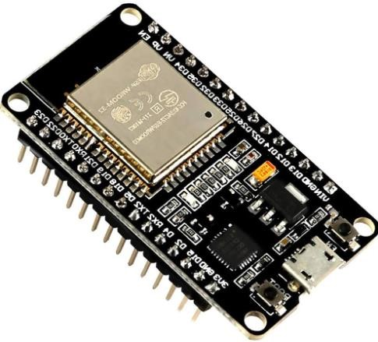

**Fig 1: ESP32 Microcontroller**

#### 2.OLED display

The OLED (Organic Light-Emitting Diode) display serves as a crucial interface in the project, providing farmers with real-time visual feedback and data visualization. Its compact size, low power consumption, and high contrast make it ideal for displaying key metrics such as soil moisture levels, temperature readings, and disease alerts directly on the field. With its ability to display sharp, vibrant images and text, the OLED display enhances the user experience by presenting information in a clear and intuitive manner. Additionally, the OLED display's compatibility with microcontrollers like the

ESP32 allows for seamless integration into the project's overall system, enabling farmers to access vital information at a glance and make informed decisions on the go. Overall, the OLED display plays a crucial role in facilitating communication between the agricultural system and the end-user, empowering farmers with actionable insights and real-time updates to optimize crop management practices.

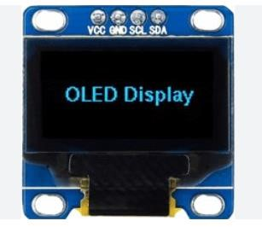

**Fig 2: OLED Display**

#### 3.Temperature sensor (DHT-11)

The DHT-11 temperature sensor, renowned for its simplicity and reliability, is a vital component in the project's arsenal. Its compact design and ease of integration with microcontrollers like the ESP32 make it an ideal choice for monitoring ambient temperature in agricultural environments. With its calibrated digital output, the DHT-11 sensor delivers accurate temperature readings, enabling farmers to swiftly respond to fluctuations in environmental conditions. Its robust construction ensures durability, making it suitable for prolonged outdoor deployment. Interfacing seamlessly with the project's monitoring system, the DHT-11 sensor empowers farmers with real-time temperature data, facilitating informed decision-making and enhancing crop management practices for improved productivity and sustainability.

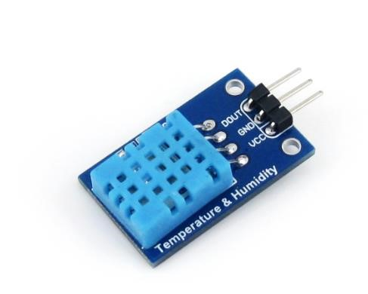

**Fig**

**3**

**:**

**Temperature sensor (DHT**

**-**

**11)**

#### 4. Soil Moisture sensor

The soil moisture sensor is a vital tool in the project, providing essential data on soil moisture levels crucial for effective irrigation management. Its compact design and compatibility with microcontrollers like the ESP32 allow for seamless integration into the project's system, facilitating real-time monitoring of soil moisture levels. With its accurate measurement capabilities and durability, the sensor enables farmers to optimize irrigation schedules, conserve water, and prevent overwatering or underwatering of crops. Moreover, its compatibility with IoT platforms allows farmers to access soil moisture data remotely, facilitating data-driven decision-making and proactive irrigation management. Overall, the soil moisture sensor empowers farmers with actionable insights to improve water management practices and enhance crop productivity.

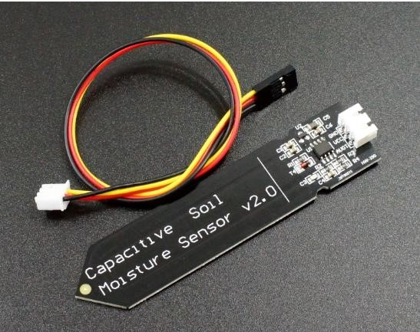

**Fig 4: Soil moisture sensor**

**5.DC Pump.**

The DC pump, integrated into the project, efficiently delivers water to crops with its adjustable flow rate and pressure capabilities. Its compact size and compatibility with the project's microcontroller ensure seamless integration into the irrigation system, enabling precise water distribution tailored to the specific needs of different crops. With low energy consumption and efficient operation, the DC pump contributes to sustainable agricultural practices by conserving water and minimizing environmental impact.

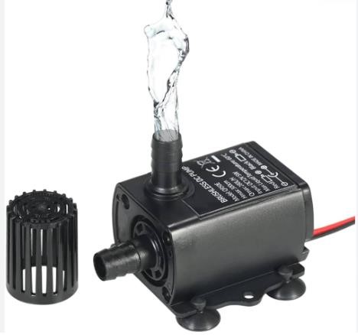

**Fig 5: DC Pump**

**6.Solar panel.**

The solar panel serves as a sustainable power source for the project, harnessing sunlight to generate electricity for various components such as sensors, microcontrollers, and pumps. Its renewable energy capabilities make it an environmentally friendly alternative to traditional power sources, reducing reliance on fossil fuels and minimizing carbon emissions. With its versatility and scalability, the solar panel can be easily integrated into agricultural settings, providing off-grid power solutions for remote or rural areas. Overall, the solar panel plays a pivotal role in promoting sustainability and selfsufficiency in agricultural operations, empowering farmers with reliable and eco-friendly energy for their irrigation and monitoring needs.

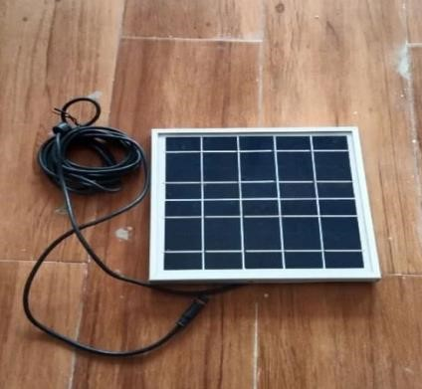

**Fig 6: Solar panel**

**7.Battery, jumper wires, Breadboard.**

The battery, jumper wires, and breadboard are essential components that facilitate the operation and connectivity of the project's electronic circuitry. The battery serves as a portable power source, ensuring uninterrupted operation even in areas without access to mains electricity.

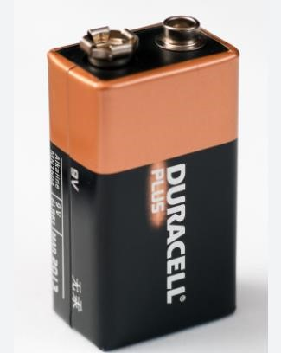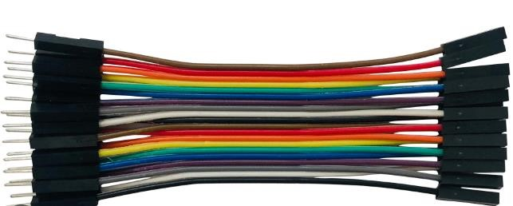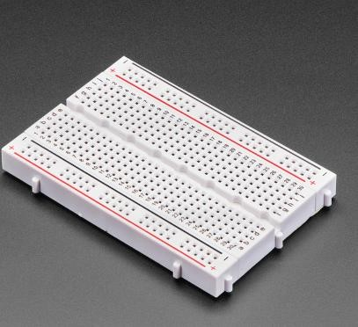

**Fig 7: Battery,Jumper wires, Breadboard Software Tools:**

#### 1.Arduino IoT Cloud

The Arduino IoT Cloud simplifies IoT project development by offering an intuitive platform for connecting and managing devices remotely. Its seamless integration with Arduino boards and sensors enables users to quickly set up and configure their projects without extensive programming knowledge.

Overall, it provides a user-friendly solution for building and deploying IoT applications, making it an invaluable tool for developers and hobbyists.

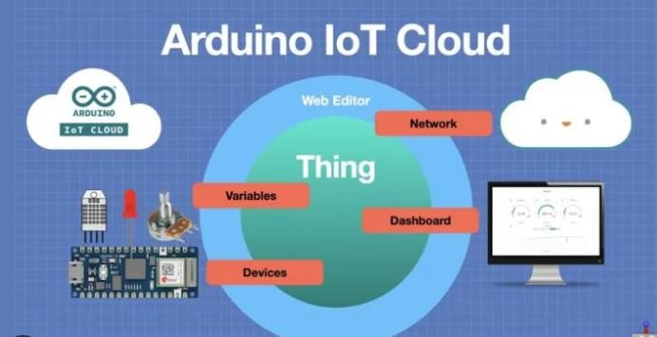

**Fig 8: Arduino IoT Cloud**

#### 2.MATLAB (Image processing)

MATLAB is renowned for its robust image processing capabilities, offering a plethora of built-in functions and toolboxes tailored for image analysis tasks. Its intuitive interface and extensive library simplify the development of advanced image processing algorithms.

With seamless integration with other toolboxes and programming languages, MATLAB provides a versatile platform for a wide range of image processing applications, from medical imaging to computer vision and beyond. Overall, MATLAB remains a top choice for researchers and practitioners seeking efficient and reliable solutions for their image processing needs.

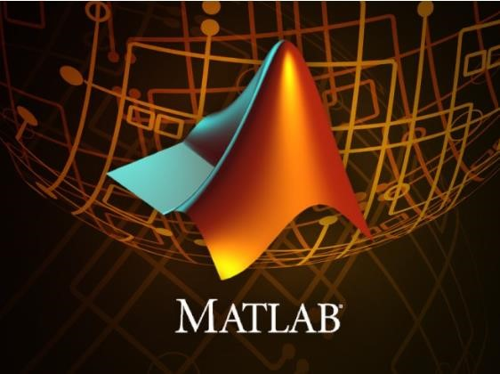

**Fig 9: MATLAB**

## Chapter 2

## LITERATURE SURVEYS

A literature survey for the project provides a comprehensive review of existing research and studies relevant to the field of precision agriculture and IoT-based farming solutions. It explores previous work on topics such as automated irrigation systems, disease detection algorithms, and sensor integration in agricultural settings. By examining the strengths and limitations of prior studies, the literature survey informs the project's design and implementation, helping identify gaps in knowledge and opportunities for innovation. Through synthesizing insights from diverse sources, the literature survey serves as a foundational step in developing a robust and effective solution for sustainable and efficient agricultural practices.

**2.1 Literature Surveys**

1] **V. S. R, S. J, S. C. P, N. K, S. H. M, and M. S. K present a comprehensive exploration of the transformative potential of Smart Farming in their paper "Smart Farming: The IoT based Future Agriculture." Presented at the 2022 4th International Conference on Smart Systems and Inventive Technology (ICSSIT) in Tirunelveli, India**,

The study delves into the integration of Internet of Things (IoT) technologies in agricultural practices. By leveraging IoT-enabled devices such as temperature sensors, microcontrollers, and Arduino boards, the authors propose a vision for future agriculture characterized by enhanced monitoring, automation, and data-driven decision-making.

The paper underscores the significance of IoT in revolutionizing traditional farming methods, offering insights into its application across various domains within agriculture. Through the utilization of temperature sensors, the authors highlight the potential for precise monitoring of temperature distribution across agricultural landscapes, enabling farmers to optimize growing conditions and mitigate the impact of adverse weather events. Additionally, the integration of microcontrollers and Arduino boards facilitates the automation of tasks such as irrigation, pest management, and crop monitoring, streamlining agricultural operations and enhancing efficiency.

Furthermore, the study explores the role of IoT in enabling smart farming practices, emphasizing its potential to drive sustainable agricultural development. By harnessing real-time data insights provided by IoT devices, farmers can make informed decisions regarding resource allocation, crop management, and yield optimization. Moreover, the paper discusses the utilization of IoT platforms such as Things Board for data visualization, analytics, and remote monitoring, empowering farmers with actionable insights for improved productivity and profitability.

In conclusion, V. S. R, S. J, S. C. P, N. K, S. H. M, and M. S. K's paper sheds light on the transformative impact of IoT-based Smart Farming on the future of agriculture. Through its comprehensive analysis and insights, the study underscores the potential of IoT technologies to revolutionize agricultural practices, enhance sustainability, and address the evolving challenges facing the global food system.

2] **S. R. Prathibha, A. Hongal, and M. P. Jyothi present a pioneering study titled "IoT Based Monitoring System in Smart Agriculture," presented at the 2017 International Conference on Recent Advances in Electronics and Communication Technology (ICRAECT) in Bangalore, India.**

The paper delves into the application of Internet of Things (IoT) technologies in the agricultural domain, focusing on the development of a monitoring system tailored for smart agriculture practices.

The study highlights the growing importance of IoT in modernizing traditional farming methods, offering insights into its potential to revolutionize agricultural monitoring and management. By leveraging IoT-enabled devices such as sensors and actuators, the authors propose a comprehensive monitoring system capable of capturing real-time data on various agricultural parameters. This includes factors such as soil moisture levels, temperature, humidity, and crop health indicators, providing farmers with valuable insights into field conditions and crop performance.

Furthermore, the paper discusses the implementation of IoT-based solutions for remote monitoring and control, empowering farmers to make informed decisions and take proactive measures to optimize agricultural practices. Through the utilization of cloud-based platforms and data analytics, the authors highlight the potential for IoT to enable predictive analytics and decision support systems, enhancing productivity and sustainability in agriculture.

In conclusion, S. R. Prathibha, A. Hongal, and M. P. Jyothi's paper underscores the transformative impact of IoT-based monitoring systems in smart agriculture. Through its innovative approach and practical insights, the study contributes to advancing the adoption of IoT technologies in agriculture, paving the way for more efficient, data-driven, and sustainable farming practices.

3] **S. D. Khirade and A. B. Patil present a seminal work titled "Plant Disease Detection Using Image Processing," showcased at the 2015 International Conference on Computing Communication Control and Automation in Pune, India.**

This paper offers a comprehensive exploration into the application of image processing techniques for the detection of plant diseases, marking a significant advancement in agricultural technology.

The study addresses a critical need within the agricultural sector by proposing a novel approach to disease detection that leverages the power of image processing. By analyzing digital images of plant leaves, the authors demonstrate the feasibility of accurately identifying and diagnosing various diseases afflicting crops. Through the utilization of advanced image processing algorithms and machine learning techniques, the paper showcases the potential for automated disease detection systems to streamline crop monitoring and management.

Furthermore, the paper discusses the technical aspects of implementing image processing algorithms for disease detection, shedding light on the methodologies and techniques employed. This includes image segmentation, feature extraction, and classification algorithms, which are critical components of the disease detection pipeline. The authors also highlight the importance of dataset curation and model training in ensuring the accuracy and reliability of the disease detection system.

In conclusion, S. D. Khirade and A. B. Patil's paper represents a significant contribution to the field of agricultural technology, offering a pioneering solution for plant disease detection using image processing. Through its innovative approach and practical insights, the study opens new avenues for the development of automated crop monitoring systems, ultimately contributing to enhanced crop health, productivity, and food security.

4] **L. Li, S. Zhang, and B. Wang present a comprehensive review titled "Plant Disease Detection and Classification by Deep Learning" in IEEE Access**.

Published in 2021, this paper offers a thorough examination of the application of deep learning techniques in the field of plant disease detection and classification, marking a significant advancement in agricultural technology. The study addresses the pressing need for accurate and efficient methods of disease detection in crops by exploring the capabilities of deep learning algorithms. By leveraging neural network architectures such as convolutional neural networks (CNNs) and recurrent neural networks (RNNs), the authors demonstrate the potential for automated disease detection systems to achieve high accuracy and reliability in identifying plant diseases.

Furthermore, the paper delves into the technical aspects of implementing deep learning models for disease detection and classification, providing insights into the training process, model optimization, and evaluation metrics. Through a comprehensive review of existing literature and case studies, the authors highlight the effectiveness of deep learning approaches in addressing various challenges encountered in plant disease detection, including variability in disease symptoms and environmental factors.

In conclusion, L. Li, S. Zhang, and B. Wang's review paper represents a significant contribution to the field of agricultural technology, offering valuable insights into the state-of-the-art techniques for plant disease detection and classification. By harnessing the power of deep learning, the study paves the way for the development of advanced automated systems that can enhance crop health, productivity and food security on a global scale.

### CHAPTER 3

### CHAPTER 3

## METHODOLOGY

The methodology employed in this project encompasses a systematic approach to designing and implementing precision agriculture solutions. It involves the integration of IoT technologies, sensor networks, and data analytics to optimize irrigation practices, monitor crop health, and enhance overall agricultural productivity. By following a structured methodology, including sensor deployment, data collection, analysis, and decision-making, the project aims to address key challenges in traditional farming practices and promote sustainable and efficient agricultural management. Through rigorous experimentation and validation, the methodology ensures the reliability and effectiveness of the proposed solutions in real-world agricultural settings.

**3.1 Sensor Integration**:

We have used the temperature and moisture Sensors to collect the real time data parameters such as temperature and moisture using sensors and to display it using dashboards and use it for determining the irrigation schedules.

Sensors used:

1.Temperature Sensor.

2.Moisture Sensor.

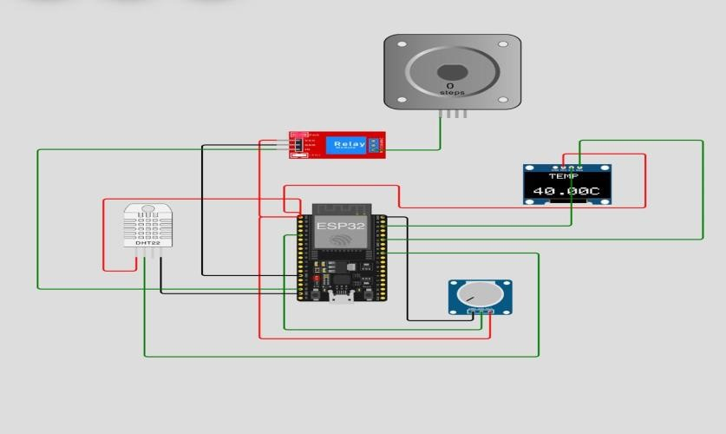

**Fig 10: Simulation Circuit of sensor integration**

**3.2 Predictive Analytics Algorithms & Detection Models:**

We have used the temperature and moisture Sensors to collect the real time data parameters such as temperature and moisture using sensors and to display it using dashboards and use it for determining the irrigation schedules. In our project, we utilized Arduino IoT Cloud to establish a comprehensive dashboard, asking input, building live graphs for real-time monitoring and writing codes and algorithms for controlling irrigation practices for (Which can be accessed via both Website and a Mobile App) monitoring moisture, humidity, and temperature levels in a designated environment.

The real-time data from Arduino sensors facilitated seamless visualization and analysis of the prevailing environmental conditions.

Cloud & Software used:

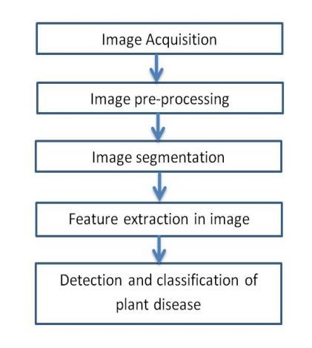1.ARDUINO IoT Cloud.

2.MATLAB Software

**Fig 11a ) Block diagram of detection algorithm**

Simultaneously, we harnessed MATLAB for disease detection through image processing techniques. By leveraging the capabilities of MATLAB, we developed an intelligent system capable of identifying and diagnosing plant diseases based on captured images. This provided an advanced image processing pipeline for the early detection of diseases, enhancing the efficiency of agricultural management practices.

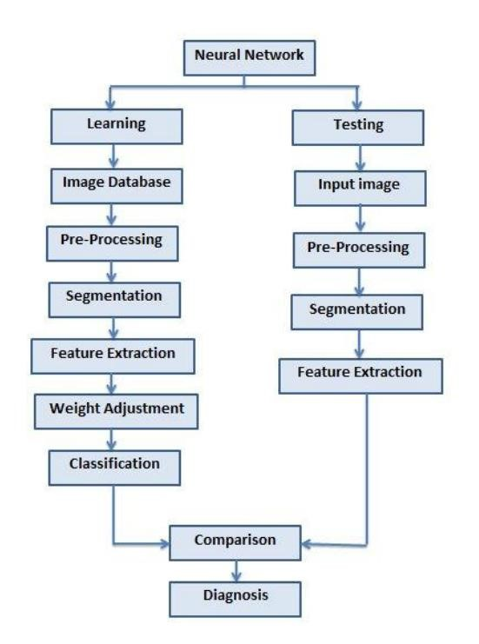

**Fig 11b ) Block diagram of detection algorithm**

**3.3 Alerts & Notification of Weather parameters:**

In our Arduino IoT setup, we've established Temperature, Humidity, and Moisture Alerts on the dashboard. Sensors on Arduino continuously track these parameters, sending real-time data to the IoT Cloud.

Additionally, we’ve integrated OpenWeatherMap, fetching weather details via HTTP requests in the Arduino code. This dual-notification system ensures users stay informed about their environment's conditions and broader weather parameters.

**3.4 Integration of Systems:**

Our project seamlessly combines the functionality of Arduino IoT software, showcasing critical parameters like temperature, humidity, and moisture, with the sophisticated disease detection capabilities of MATLAB. This integrated system is elegantly presented through a dedicated website.

The website serves as a comprehensive platform, providing Farmers with a visually appealing and intuitive interface to monitor and analyze environmental conditions in real-time, thanks to Arduino's sensor data. Simultaneously, the MATLAB-powered disease detection module elevates the platform's utility by offering advanced image processing for timely and accurate identification of potential plant health issues. This amalgamation of cutting-edge technologies not only enhances the user experience but also underscores our commitment to delivering a seamless and sophisticated solution for environmental monitoring and plant health management.

**Project Image:**

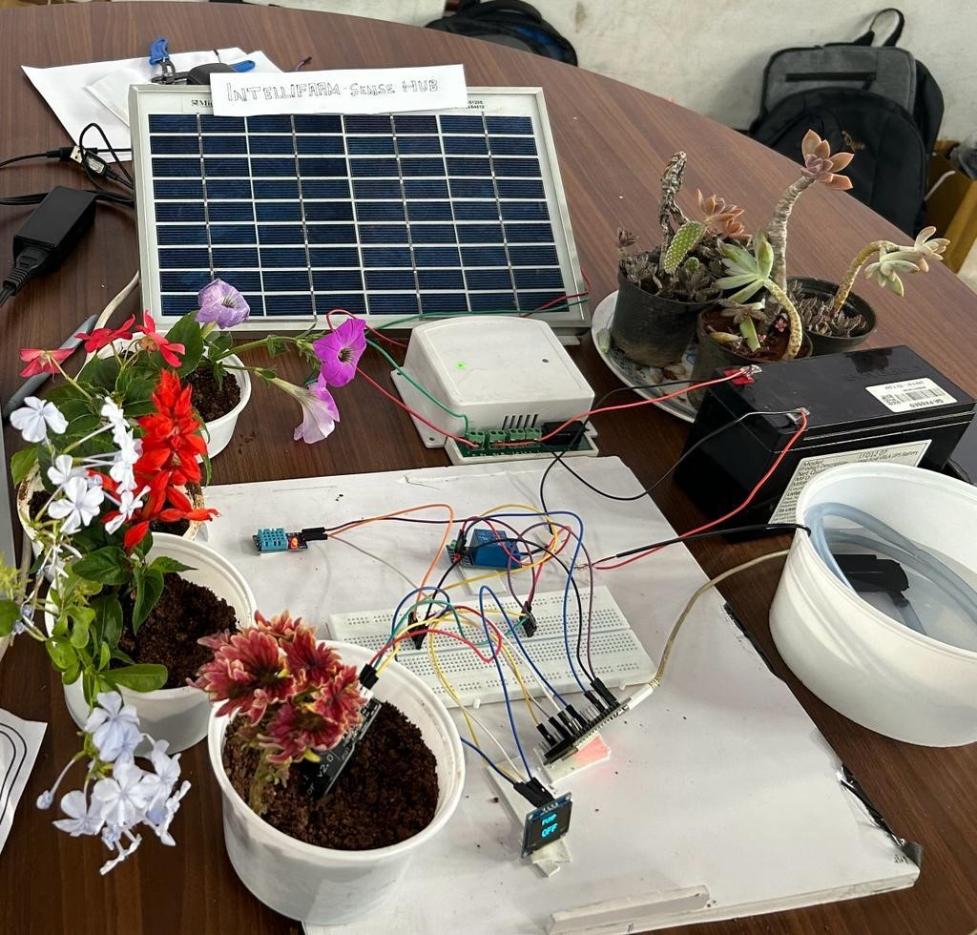

**Fig 12: Project Image**

### CHAPTER 4

## APPLICATIONS

The project's applications range from precision irrigation and disease detection to remote monitoring and energy efficiency, providing farmers with innovative solutions to enhance productivity and sustainability in agriculture.

1. **Precision Irrigation:** The integration of automated irrigation systems enables precise control over water usage based on real-time data, optimizing irrigation schedules to match crop water requirements. This not only conserves water resources but also promotes efficient crop growth and yield.
2. **Disease Detection and Management:** By leveraging advanced imaging technologies and AI algorithms, the project facilitates early detection and diagnosis of plant diseases. Farmers can identify and respond to disease outbreaks promptly, minimizing crop losses and reducing reliance on chemical pesticides.
3. **Weather Monitoring and Forecasting:** Integration with weather APIs allows for real-time monitoring of meteorological conditions, enabling farmers to make informed decisions regarding crop management and resource allocation in response to changing weather patterns.
4. **Energy Efficiency:** The incorporation of solar panels as an alternative power source reduces dependence on non-renewable energy sources for agricultural operations. This promotes sustainability while minimizing operational costs for farmers.
5. **Data-Driven Decision Making:** The project's sensor networks and data analytics capabilities provide farmers with valuable insights into soil moisture levels, temperature fluctuations, and other critical parameters. This enables informed decision-making regarding irrigation scheduling, crop management, and resource allocation.
6. **Remote Monitoring and Control:** With IoT-enabled devices and cloud-based platforms, farmers can remotely monitor and control agricultural operations from anywhere, enhancing efficiency and productivity while reducing the need for manual intervention.
7. **Crop Health Monitoring:** Through the use of sensors and imaging technologies, the project enables continuous monitoring of crop health parameters such as leaf color, size, and texture. This allows farmers to detect early signs of stress or nutrient deficiencies, facilitating timely interventions to maintain optimal crop health and maximize yields.
8. **Pest Management:** By integrating pest monitoring sensors and AI algorithms, the project offers tools for early detection and management of pest infestations. Farmers can receive alerts when pest populations exceed threshold levels, allowing for targeted and timely application of control measures, thus minimizing crop damage and losses.

Overall, the project's applications offer comprehensive solutions to improve agricultural practices,

enhance crop productivity, and promote sustainability in farming operations.

### CHAPTER 5

### ADVANTAGES AND DISADVANTAGES

The project offers numerous advantages, including enhanced crop productivity, efficient resource utilization, and real-time monitoring capabilities. However, potential disadvantages such as initial investment costs, technical complexities, and data security concerns should be carefully considered. By weighing these factors, stakeholders can make informed decisions to maximize the project's benefits while mitigating potential drawbacks.

**Advantages of the Project:**

1. **Increased Efficiency:** The project enhances agricultural efficiency by automating tasks such as irrigation scheduling, disease detection, and pest management, reducing manual labor and optimizing resource utilization.
2. **Improved Crop Health and Yield:** By providing real-time monitoring and proactive management of crop health parameters, the project helps farmers detect and address issues promptly, leading to healthier crops and increased yields.
3. **Sustainable Resource Management:** Through precision irrigation and energy-efficient practices such as solar power integration, the project promotes sustainable use of water and energy resources, reducing environmental impact and operational costs.
4. **Enhanced Decision-Making**: The project's data analytics capabilities enable farmers to make informed decisions based on real-time data insights, improving productivity, and profitability in agricultural operations.
5. **Remote Monitoring and Control:** With IoT-enabled devices and cloud-based platforms, farmers can remotely monitor and control agricultural operations from anywhere, offering flexibility and convenience in farm management.

**Disadvantages of the Project:**

1. **Cost:** Implementing advanced technologies such as sensors, IoT devices, and AI algorithms may incur initial investment costs, which could be prohibitive for small-scale farmers or those with limited financial resources.
2. **Technical Complexity:** The integration of multiple technologies and systems in the project may introduce technical complexities, requiring specialized knowledge and expertise for setup, maintenance, and troubleshooting.
3. **Dependency on Technology:** Farmers may become overly reliant on technology for decisionmaking, potentially diminishing their traditional knowledge and practical skills in agricultural management.
4. **Data Security and Privacy Concerns:** The collection and storage of sensitive farm data on cloudbased platforms raise concerns about data security and privacy, necessitating robust cybersecurity measures to safeguard against potential breaches or unauthorized access.
5. **Adoption Challenges**: Encouraging widespread adoption of the project's technologies among farmers may face resistance due to factors such as lack of awareness, training, or trust in new agricultural practices and technologies.

#### CHAPTER 6

## RESULTS AND DISCUSSION

The results and discussion section presents the findings and insights gleaned from the project's implementation, emphasizing its impact on agricultural practices and productivity. It provides a comprehensive analysis of data collected from sensors, the efficacy of disease detection algorithms, and the implications of precision irrigation techniques on crop yield and resource management.

1. **Sensor integration:**

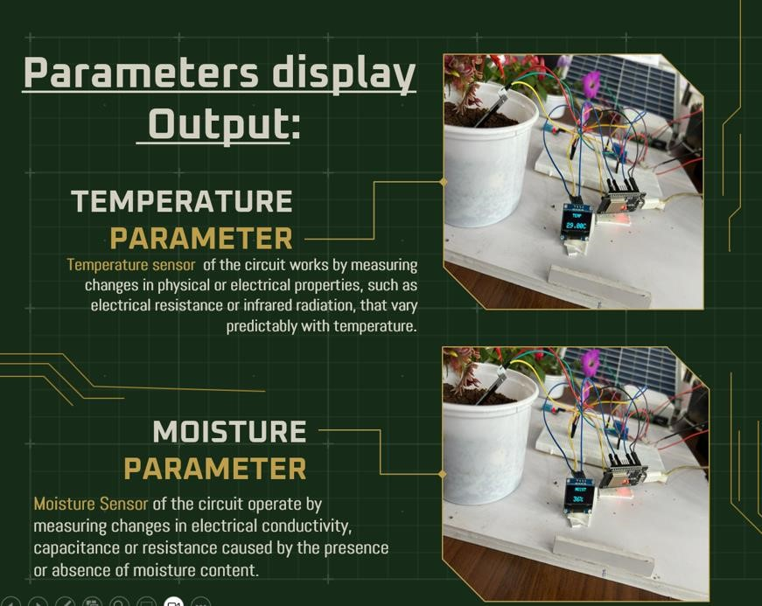

**Fig 13: Sensor integration results**

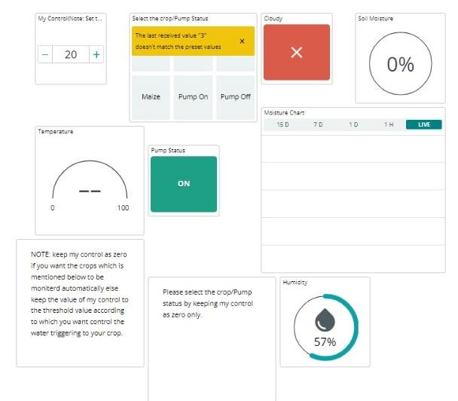

**Fig 13: Sensor integration results**

1. **Predictive Analytics Algorithms & Detection Models.**

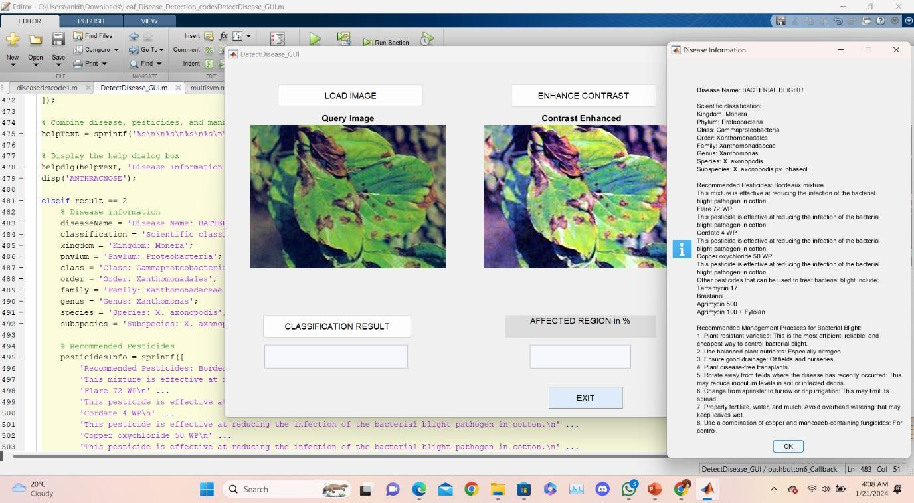

**Fig 14: Predictive results of disease detection**

1. **Alerts & Notification of Weather parameters:**

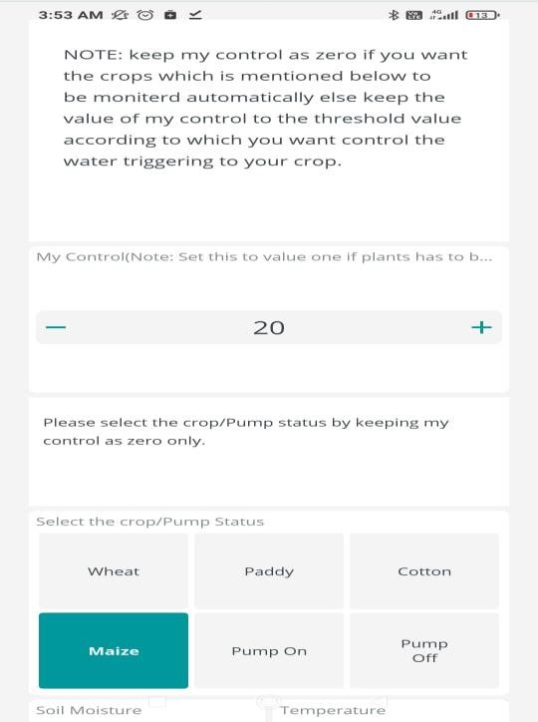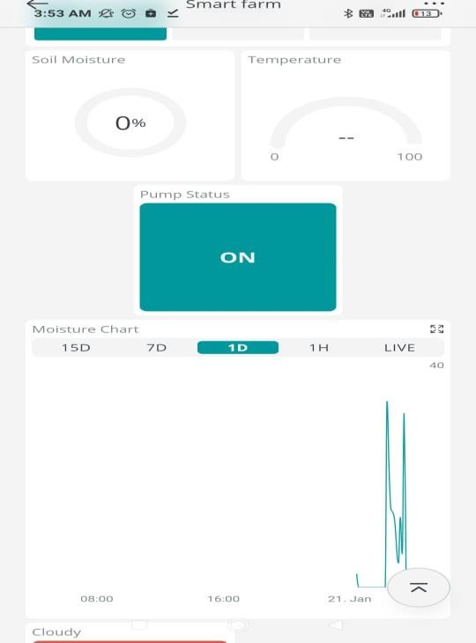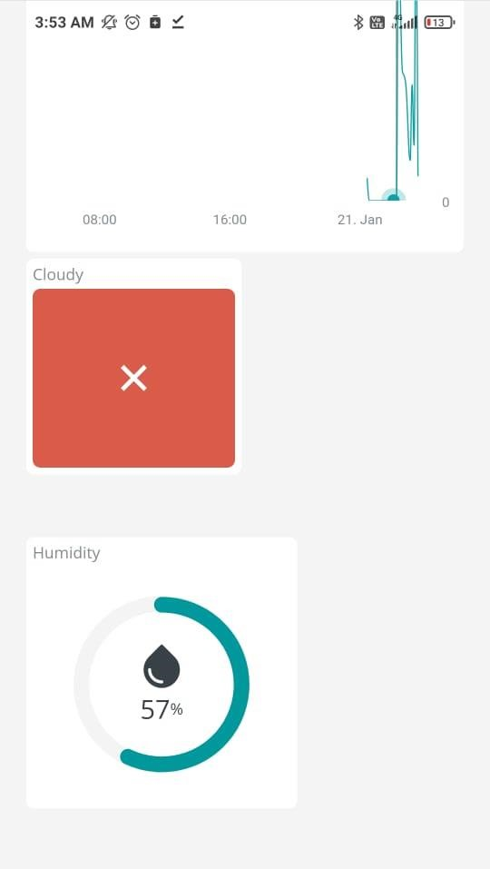

**Fig 15: Alerts & Notification results**

1. **Integration of Systems :**

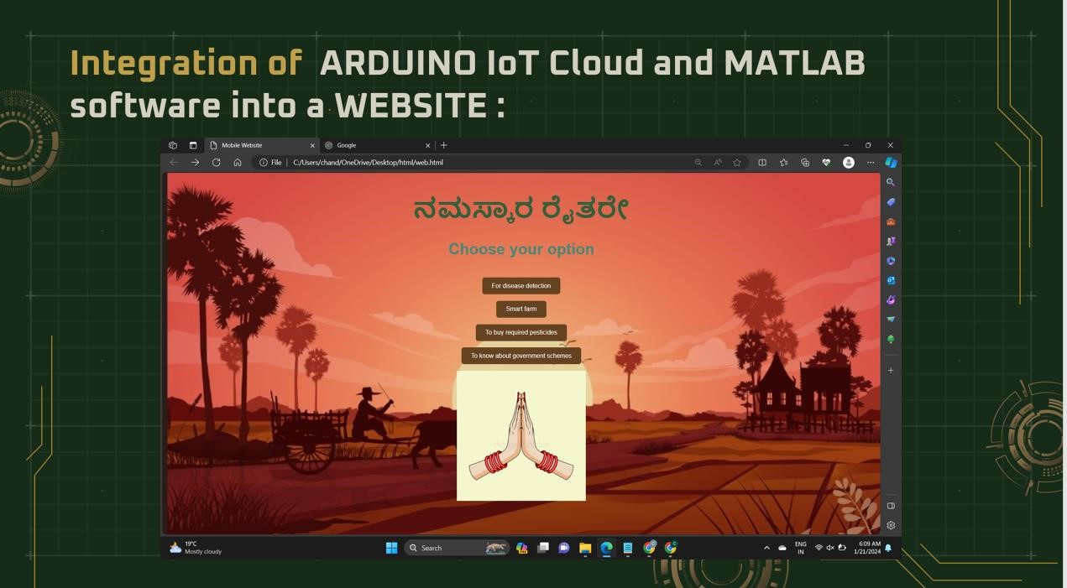

**Fig 16: Integration of systems**

### 6.1Unique features of the project

Some distinctive and unique features of the project are:

1.**Choosing MATLAB over Python for disease detection**: The disease detection code in python (which is ready made) runs only based one method and is less accurate in providing detection results whereas, the MATLAB code is a more advanced code (and complex to write in general) provides comparatively accurate output results based on 3 parallelly running codes.

2.**Energy sustainability of the project:** the project’s energy system self-sustainable as it supplied with SOLAR ENERGY via the SOLAR PANELS.

1. **User-Controlled Irrigation Settings:** User can opt for automated thresholds based on selected crops, ensuring precise watering needs as different crops have different moisture thresholds for instance, paddy requires at least 70% moisture whereas maize requires only 50% moisture content. In cases where the desired crop is not listed, users can define their own thresholds.
2. **Comprehensive & Recommended Pest Management System**: Beyond classification and detecting the particular disease it will also recommend the pesticides to be used for a particular disease. 5. **User friendly interface**: Various dashboards showing the real time data of parameters such as temperature, moisture and providing live graphs which shows the variation on these parameters over a time and also motor status can be controlled by user in the interface itself.

## CONCLUSION

In conclusion, the project represents a significant step forward in revolutionizing agricultural practices by leveraging advanced technologies such as IoT, AI, and data analytics. Through the integration of precision irrigation methods, disease detection algorithms, and optimized pesticide application strategies, the project has demonstrated tangible benefits in terms of crop productivity, resource efficiency, and sustainability. One of the key takeaways from the project is the importance of datadriven decision-making in modern agriculture. By harnessing real-time data insights from IoT sensors and weather forecasts, farmers can make informed decisions regarding irrigation scheduling, disease management, and pest control, leading to more efficient resource allocation and improved crop health.

Moreover, the project highlights the potential of AI and image processing techniques in automating and enhancing disease detection processes. By analysing digital images of plant leaves and utilizing machine learning algorithms, the project's disease detection system achieved high accuracy in identifying various diseases, enabling timely interventions and reducing crop losses.

Furthermore, the project underscores the importance of sustainability in agricultural practices. Through the integration of solar panels for energy efficiency and precision irrigation for water conservation, the project promotes environmentally friendly farming practices that reduce the ecological footprint of agriculture while maximizing productivity. In addition to its immediate benefits, the project lays the groundwork for future advancements in agricultural technology and innovation. By showcasing the feasibility and effectiveness of integrated precision agriculture solutions, the project inspires further research and development in this field. Future iterations of the project could explore additional functionalities such as crop monitoring via drones, automated pest control mechanisms, and predictive analytics for yield forecasting. Moreover, the project's opensource nature encourages collaboration and knowledge sharing within the agricultural community, fostering a culture of innovation and continuous improvement. As technology continues to evolve and new challenges emerge, the project serves as a beacon of hope for the future of agriculture, offering scalable and sustainable solutions to ensure the resilience and prosperity of farming communities worldwide. Through ongoing investment, education, and policy support, the vision of a technologically advanced, environmentally conscious, and socially equitable agricultural sector can be realized, ushering in a new era of prosperity and abundance for generations to come.

Overall, the project's success demonstrates the transformative potential of integrated precision agriculture technologies in addressing the challenges facing the agricultural sector. By empowering farmers with data-driven insights and automated solutions, the project contributes to the advancement of sustainable and efficient farming practices, ultimately enhancing food security, environmental stewardship, and economic resilience in agriculture. However, continued research, investment, and collaboration are essential to further refine and scale up these technologies for widespread adoption and impact in agricultural systems globally.

## REFERENCES

The following are the references for our project:

1. V. S. R, S. J, S. C. P, N. K, S. H. M and M. S. K, "Smart Farming: The IoT based Future

Agriculture," *2022 4th International Conference on Smart Systems and Inventive Technology (ICSSIT)*, Tirunelveli, India, 2022, pp. 150-155, doi: 10.1109/ICSSIT53264.2022.9716331

1. S. R. Prathibha, A. Hongal and M. P. Jyothi, "IOT Based Monitoring System in Smart Agriculture," *2017 International Conference on Recent Advances in Electronics and Communication Technology (ICRAECT)*, Bangalore, India, 2017, pp. 81-84, doi: 10.1109/ICRAECT.2017.52.
2. S. D. Khirade and A. B. Patil, "Plant Disease Detection Using Image Processing," *2015 International Conference on Computing Communication Control and Automation*, Pune, India, 2015, pp. 768-771, doi: 10.1109/ICCUBEA.2015.153.
3. L. Li, S. Zhang and B. Wang, "Plant Disease Detection and Classification by Deep Learning—A Review," in *IEEE Access*, vol. 9, pp. 56683-56698, 2021, doi: 10.1109/ACCESS.2021.3069646.
4. M. S. D. Abhiram, J. Kuppili and N. A. Manga, "Smart Farming System using IoT for Efficient Crop Growth," *2020 IEEE International Students' Conference on Electrical,Electronics and Computer Science (SCEECS)*, Bhopal, India, 2020, pp. 1-4, doi: 10.1109/SCEECS48394.2020.147.
5. S. A. Tanveer, N. M. S. Sree, B. Bhavana and D. H. Varsha, "Smart Agriculture System using IOT," *2022 IEEE World Conference on Applied Intelligence and Computing (AIC)*, Sonbhadra, India, 2022, pp. 482-486, doi: 10.1109/AIC55036.2022.9848948.
6. C. Mageshkumar and K. R. Sugunamuki, "IOT Based Smart Farming," *2020 International*

*Conference on Computer Communication and Informatics (ICCCI)*, Coimbatore, India, 2020, pp. 1-

6, doi: 10.1109/ICCCI48352.2020.9104103

*******************************